Documentation for

Time – Locked Simulators

Suarez Lab | Queensland Brain Institute
Version: 1.1

Author: Tevyn Vergara

Hardware Requirements for computer:
With Dongle:
- x1 Audio Jack
- x1 USB-C Port
- x3 Standard Outlets (Can use a power board)
Without Dongle:
- x1 Audio Jack
- x1 Ethernet Port
- x2 USB-A Ports
- x3 Standard Outlets (Can use a power board)
*See hardware diagram at back of doc for wiring guide*

Software Requirements
- GitHub + Git – for getting code incase you don’t have it installed
- VSCode – main platform for using/testing program

Once VSCode is installed, install these in extensions:
- Python by Microsoft
- Pylance by Microsoft
- C/C++ by Microsoft
- Platform IO by Platformio.org

PIP installs required:
- Pyserial
- Sounddevice
- Numpy
- DepthAI
- Opencv-python

Other Installs:
- Winget install gyan.ffmpeg (then reinstall)

How to Install
NOTE: Just ask GPT if you’re confused
- Create a Github account if you don’t have program locally available:
https://docs.github.com/en/get-started/start-your-journey/creating-an-account-on-github

- If you haven’t already: download and install git:
https://git-scm.com/install/

- Set up your Github account on Git:
https://docs.github.com/en/get-started/git-basics/set-up-git

- Download and install VSCode:
https://code.visualstudio.com/download

- Sign into your Github account on VScode:
https://code.visualstudio.com/docs/sourcecontrol/github#_setting-up-a-repository

- In VSCode, find and install these extensions:
  - Python by Microsoft (make sure to add Python to PATH)
  - Pylance by Microsoft
  - C/C++ by Microsoft
  - Platform IO by Platformio.org

- Open a new terminal and then navigate to a desired working folder

- Clone the repository here (you can copy paste this):

Git clone https://github.com/Noodle-Box/QBI_VibrationBox_10968.git

- Install these PIP install packages (you can copy paste this):

python -m pip install pyserial sounddevice numpy depthai opencv-python

- Also install this package:

Winget install Gyan.FFmpeg

Equipment Calibration
In order to ensure that the equipment is being read into the computer, we need to configure them before setting up their parameters

Speaker
- Plug in the audio jack onto the computer end and turn on speaker

- Try playing music/sounds and ensure the connection is working

Camera
Model: Luxonis OAK_D PoE
- Navigate to the \...\Python Files folder in VS code terminal (cd '.\Python Files\')

- Copy paste this into the terminal:
python .\Main.py --list-cameras

- If the dongle/ethernet cable connection is working then something like this should appear:

- Copy the IP address

- In Main.py, find the CAMERA_IP Macro and set the IP address to that variable.

Microphone
Model: Batsound Pettersson M500-384kHz USB Ultrasound Microphone
- Navigate to the \...\Python Files folder in VS code terminal (cd '.\Python Files\')

- Copy paste this into the terminal:
python .\Main.py --list-devices

- You will see all device drivers registered/connected to the computer device manager

- If you can’t see the microphone devices, try this:
python .\Main.py --list-devices --filter “Pettersson”

- If the dongle/ethernet cable connection is working then something like this should appear:

- Take note of the System Index which the device that has Sampling Freq: 384000 Hz.

- In Main.py, find the CAMERA_IP Macro and set the IP address to that variable.

Motor Driver
- Navigate to the \...\Python Files folder in VS code terminal (cd '.\Python Files\')

- Copy paste this into the terminal:

[System.IO.Ports.SerialPort]::getportnames()

- If Arduino Motor Driver is plugged in correctly, then a COM port should appear. Example: COM6

- In Main.py, find the MOTOR_SERIAL_PORT Macro and set the com port to the Arduino Port

Setting up the experiment
All the configurations and setup is done in Main.py in a section called “Peripheral Settings”. Everything else is code functionality. You can configure almost everything here.
The program is set to output these three things:
- Audio file set to .FLAC
- Video output set to .h265
- A merged mp4 of the audio merged with the camera visual
All output files are formatted: Recording_(timestamp)_(day)_(month)

First configure these:
- Change CUSTOM_RECORDINGS_DIR desired folder to keep recordings (absolute path)
- DEFAULT_RECORD_TIME desired experiment duration in (s)
- DEFAULT_MERGE_AV Set true to see visual with audio. Can disable with “False” and just get the separate visual and audio outputs

Now the peripheral settings:
Camera:
- Change CAMERA_VIEW to toggle the different viewing options (center RGB, left, right and stereo B/W)
Speaker:
The speaker produces a beep sound in the structure of a sinusoid.
- Frequency can be adjusted to desired tone with SPEAKER_FREQ
- Beep ON and Beep OFF time is also adjustable with SPEAKER_ON and SPEAKER_OFF
Motor:
The motor has three main parameters:
- Motor strength (how strong the vibration is) with MOTOR_STRENGTH
- Vibration ON and OFF time with MOTOR_ON_TIME and MOTOR_OFF_TIME

Running the experiment
In terminal, input this to enable all four peripherals
Python .\Main.py --set-all on
You’ll see something like this:
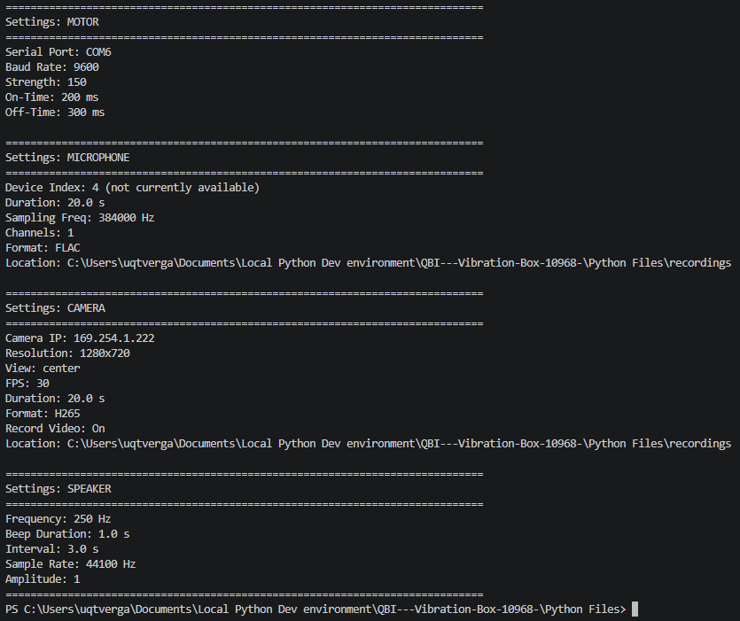
This takes all the changes you made in Main.py and updates it into the run-files
If you need to tweak the parameters, make sure to do this command every single time

For mor information type:
python .\Main.py –info
You’ll get full information about the record time and merge toggle:
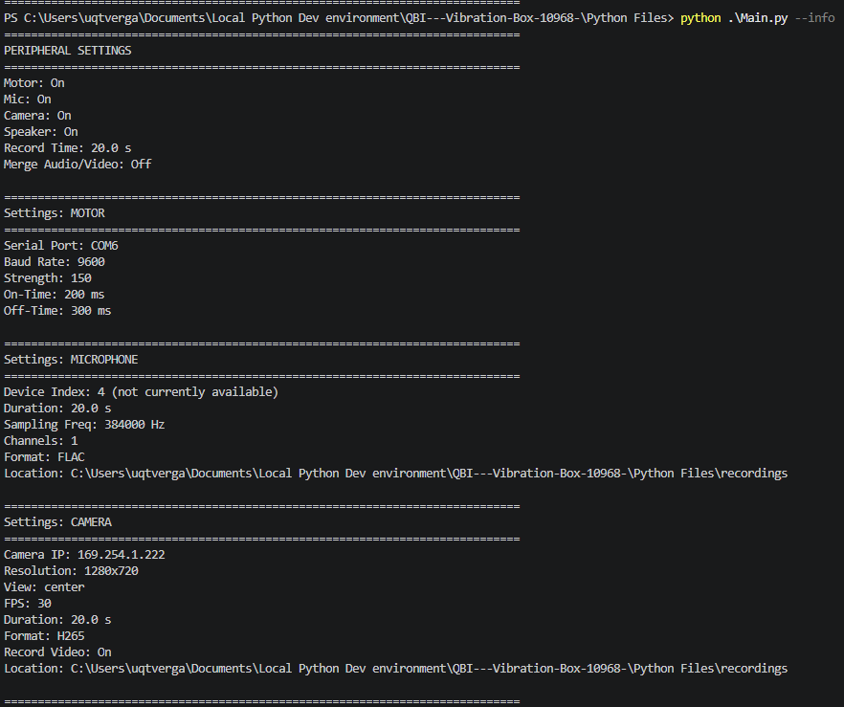

If all parameters look good, use this to run the experiment:
python .\Main.py
A new tab will open the live feed of the camera:
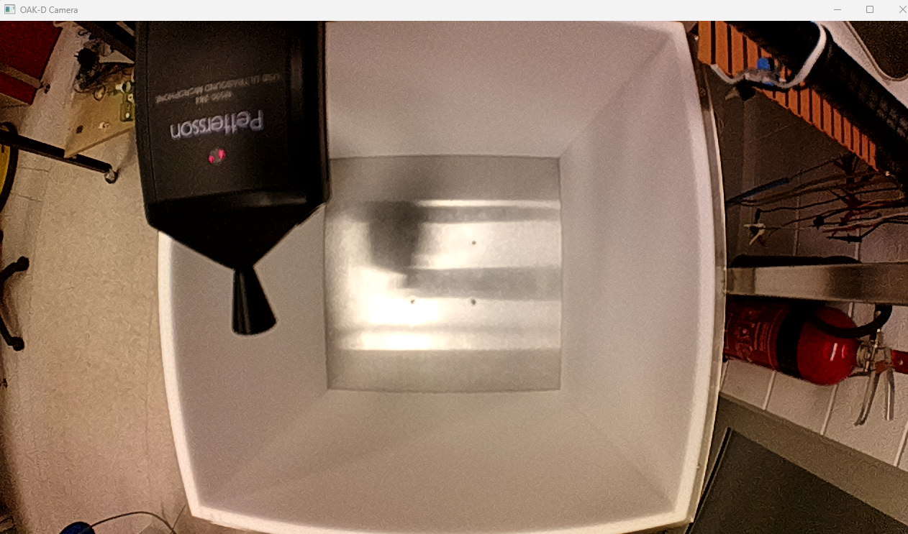
In addition to this, you’ll be able to control the motor and speaker parameters in real time as long as the experiment duration has not yet expired or killed switch was pressed:
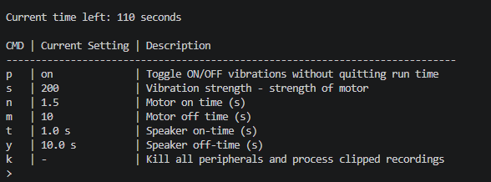
For example, if you want to set s to 100, type:
s 100 *enter key*

Summary Sheet
In the folder above the folder where main.py is located is a Summary Sheet excel file:
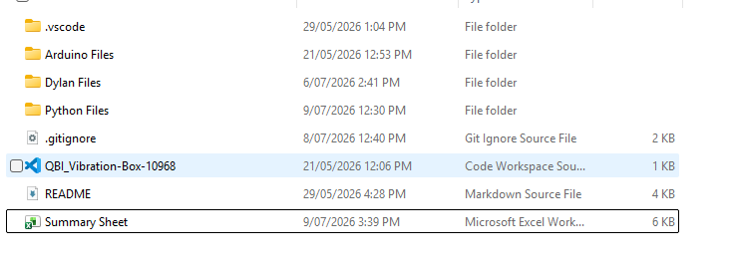
The excel file marks down all important parameters and is marked on the first column by the timestamp of the run. It matches the output files and follows:
Timestamp: Name of the file
Recording Duration: How long the recording actually recorded (clipped by kill switch)
Speaker
Speaker On: If the speaker was toggled ON/OFF
Speaker Frequency: Set frequency of pulse wave beep from speaker
Speaker On times (s): Log of preset and changed values to speaker ON time settings
Speaker Off times (s): Log of preset and changed values to speaker OFF time settings
Speaker Pulses (Real life time): Timestamps of speaker beep in real life time
Speaker Pulses (Simulation time): Timestamps of speaker beep in simulation time duration
Camera
Camera On: If the camera was toggled ON/OFF
View Mode: The view mode of the camera. Options – “left”, “right”, “center”, “stereo”
Microphone
Microphone On: If the microphone was toggled ON/OFF
Motor
Motor On: If the motor was toggled ON/OFF
Motor Strength: PWM strength of motor. Recommended range - [30, 250]
Motor On Time (s): Log of preset and changed values to motor ON time settings
Motor Off Time (s): Log of preset and changes to motor OFF time settings
Motor Pulses (Real Time): Timestamps of motor driver vibration in real life time
Motor Pulses (In Simulation time): Timestamps of motor driver vibration in simulation time duration
Output files
FLAC Out: T/F if audio fie was outputted
H265 Out: T/F if audio fie was outputted
MP4 Out: T/F if audio fie was outputted

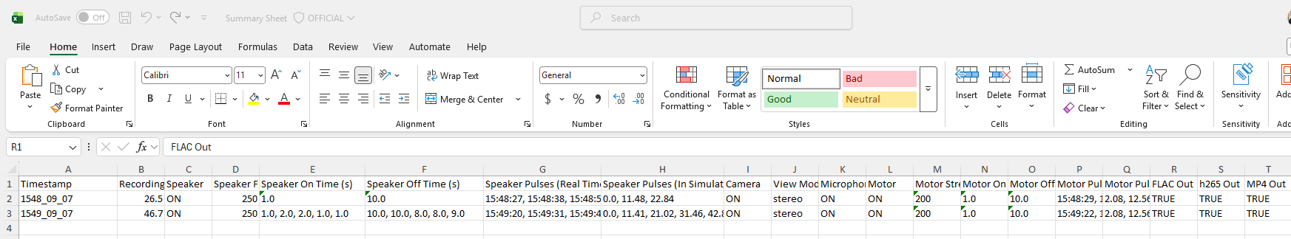

Future Improvements Coming:
- Ability to pre-set timed beeps and motor pulses during simulation duration
- GUI

Electrical Wiring Schematic
